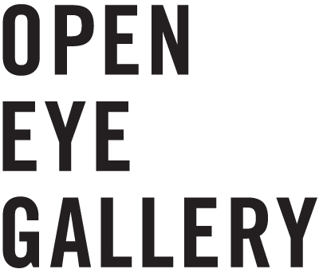
Open Eye Gallery
19 Mann Island
Liverpool Waterfront
L3 1BP

www.openeye.org.uk

+44 (0) 151 236 6768
info@openeye.org.uk

Company Limited by Guarantee No.1204519 &
Registered Charity No.1056743

GROUP BOOKING FORM

Contact Name
Contact Number
Contact E-Mail
School/Organisation Name
Course
Date of Visit
Time of Visit
Number of People Attending

Group Visit – Self led | Yes / No
Entry to Open Eye Gallery is free and our experienced Gallery Assistants are on hand to give a brief introduction to the gallery and the current exhibition (subject to availability). Due to the staffing restrictions all group visits must be booked in advance.

Exhibition Tour - £4 per person | Yes / No
The gallery is available to provide guided exhibition tours at £4 per person, depending on availability. As well as offering further insight to our current exhibitions, the guided tours can be tailored to your syllabus, research priorities and specific areas of interest. (Guided tours taking place on or before 16 October 2016 are free)

Do you have any specific access requirements?
Does any of the group have a medical condition or are on medication?
(This information is confidential & is for Open Eye Gallery staff in the case of an emergency.)
Any other comments.

Please email the completed form to adele@openeye.org.uk
GROUP VISIT INFORMATION

Open Eye Gallery welcomes all visitors, but please remember to be respectful of other visitors and the gallery itself.

Please remember the following;

- No touching of artwork: framed or unframed.

- Photography is allowed, but NO flash or Close Ups of the Artworks. If you intend on using the images for a blog or review, please tag Open Eye Gallery.

- DO NOT take items from the gallery shop into other gallery areas without purchasing them first.

- The LIFT is for visitors who need assistance getting to the first floor; please use the stairs if you are able.

- No food or drink is to be consumed in the gallery.

- There are no cloak room facilities, all belongings will need to be kept with visitor/s at all times.

- Students receive 10% off in our independent shop with a valid ID card. The shop stocks a variety of artists monographs, theory books, cameras, film, darkroom chemicals and more.

If you have any enquiries, please do not hesitate to contact the gallery by email, telephone or ask a member of staff.

+44 (0) 151 236 6768
adele@openeye.org.uk

