FREELANCE PHOTOGRAPHER IN RESIDENCE
AT THE WATCH FACTORY, RESIDENTIAL EXTRA CARE LIVING, PRESCOT
CALL OUT FOR EXPRESSION OF INTEREST

ABOUT THE COMMISSION

Open Eye Gallery are working in partnership with Community Integrated Care to establish a photographer in residence programme within the Extra Care setting of the Watch Factory building and its surrounding neighbourhood community.

A photographer/s will be commissioned to work on a year long project with local tenants, both living within the Watch Factory and its local area. The project aims to connect this recently developed heritage site with the local community, using the rich heritage of the building and associated archival imagery as a stimulus for discussion and creative activity. The majority of residents both within the Watch Factory and surrounding the building are Over55 but the project looks to explore intergenerational engagement throughout the activity.

The project will result in a permanent display of new photographic work, exhibited within the Watch Factory building. The longer-term aim is to establish a local photography group, who will continue to run as a self sustainable initiative once the photographer has finished his/ her initial residency. Partners will ensure materials and equipment will be purchased for the project and the local community with this in mind.

MORE ABOUT THE WATCH FACTORY

The Watch Factory is a state-of-the-art specialist Extra Care service in Prescot, Knowsley. The service, which opened in 2017, offers 70 purpose-built flats, which are specially designed to promote the independence of older people. It features a range of special facilities to promote the health, independence and social connection of tenants, including a bistro restaurant (which is open to the public), extensive gardens, hobby and activities rooms, and a hairdressing salon.
Community Integrated Care, as the specialist care provider for the site, sees this photography project as a vital opportunity to bring tenants together – helping to develop a community and new friendships, tackling isolation, and offering opportunities for self-expression and cultural learning.

MORE ABOUT THE COMMISSIONERS

Open Eye Gallery is one of the UK’s leading photography spaces. We present an international programme of contemporary photography exhibitions at our Liverpool Waterfront gallery, elsewhere in the UK, and further afield. We also programme workshops, talks and evening events, and house a permanent archive of diverse photographs. We deliver an on-going socially engaged programme of residencies and collaborative projects between practitioners and our local community. This particular commission opportunity is part of a Young at Art initiative, which is a long term-project working with over 60s across the Liverpool city region to create a new cultural network with an active sense of digital agency. The project is delivered by Open Eye Gallery in partnership with FACT and National Museum's Liverpool and is funded as part of the £3 million celebrating age scheme by Arts Council England and the Baring Foundation.
Please note as part of this programme Open Eye Gallery has a long standing collaboration with a group of Over60s residents from Northwood Kirkby (also in the Knowsley Borough). We would like to extend an invitation for this group to meet the new group at Watch Factory at the beginning of the project, to ‘show and tell’ how they have approached their project previously and to potentially connect the two groups longer term.
Community Integrated Care is one of Britain’s biggest and most successful social care providers. It supports around 4000 people who have learning disabilities, autism, mental health concerns and dementia, and other care and support needs, across England and Scotland.
The charity was created 31 years ago to lead the care in the community agenda and has a proud heritage in creating much of the social inclusion that is core to society today. In the present day, it nationally recognised as leading innovators in care. It is the current Charity Times ‘Charity of the Year’ and has received many of the sector’s biggest accolades, including from Skills For Care, the National Care Awards and the National Dementia Care Awards.

THE ROLE OF THE PHOTOGRAPHER

Open Eye Gallery and Community Integrated Care are keen to work with the best photographer/s interested in exploring the power of photography with a diverse range of people, developing visual narratives that are meaningful to them.

We recognise that photographers will have established different processes for engaging with communities, which may range from the co-authoring of the projects (including creating work in dialogue with communities), and / or supporting participants in creating photographic stories themselves and supporting the editing process – or a mixture of all of these.

PHOTOGRAPHER’S BRIEF

The Photographer will be expected to:

• Deliver up to 22 half day afternoon sessions with the residents plus up to 3 additional internal review and reflection meetings (to be negotiated between the community and Head of Engagement for dates).

• Attend up to 2 wider artist sharing labs during the projects duration to share feedback and peer review of other current projects being delivered within the Young at Art & Paul Hamlyn funded programmes.

• Work collaboratively with residents and two Community Integrated Care staff members who are also photographers to support them to continue a sustainable photography group once the residency comes to an end.

• To work with the Open Eye Gallery’s Head of Engagement, Curator and project participants to discuss the selection and preparation of their work for a physical and digital exhibition (please note this will be within the community setting but has the potential opportunity of touring in a different context to Open Eye Gallery at a later date)

• Contribute to the monitoring data and evaluation reporting

• Contribute up 1-2 written reflective blogs/ video interviews about the project, for the Open Eye Gallery website, associated Socially engaged photography network (SEPN) and/ or blogs for Community Integrated Care marketing purposes.

*There are a number of photography collections based both at Open Eye Gallery, onsite at the Watch Factory and at the local Prescot Museum, which you may find of interest to connect to and work with through this project. Access can be made to both archives upon request.

BUDGET

- Artist fee (based on an estimated 21 half day sessions including a planning day site visit @ £200) - £4200

- Materials / Kit for workshops and delivery - £1300

- Artist travel - £400

- There is an additional budget for participant access costs, marketing and exhibition production, which will be discussed and finalised with the successful candidate

SUBMISSION DETAILS AND SCHEDULE
Deadline for submission of interest: 10am, Monday 23 March 2020

- Please submit up to 2 A4 sides describing why you are interested in the role and potential lines of enquiries / approaches to practice you would like to deliver through this project (please consider the project aims within this proposal)
- A current CV
- Up to 8 images / video links exemplifying your work which you feel is most relevant to this project.

Shortlisted candidates informed: Monday 30 March 2020

Potential interviews for candidates will take place on site at the Watch Factory in Prescot in April (exact dates tbc)

- Project start date: Planning meetings and site visits May 2020

- Project timeline: Sessions begin in early June 2020 (exact dates to be confirmed with successful candidate). Sessions are expected to run until October 2020
- Exhibition to be produced between November 2020 - January 2021 (exact dates tbc depending on progress of project).

- Activity will take place on a weekly basis until a group is established and the photographer and group may change the date, time and frequency of sessions based on what works best for them.

- February – March 2021 - Internal evaluation and reporting

PLEASE SUBMIT YOUR COMPLETED APPLICATION INCLUDING THE PROVIDED EQUAL
OPPORTUNITIES FORM TO liz@openeye.org.uk

As part of our ongoing commitment to supporting the development and championing of socially engaged photography practice, we can provide feedback on applications If unsuccessful via email if requested.

This project is a partnership with:

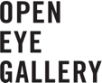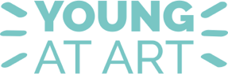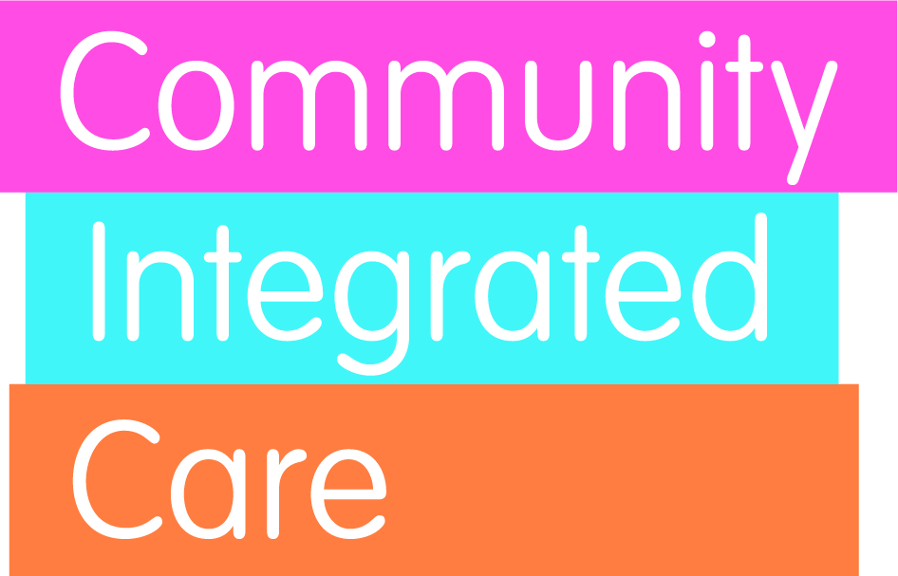

And has been supported by:

