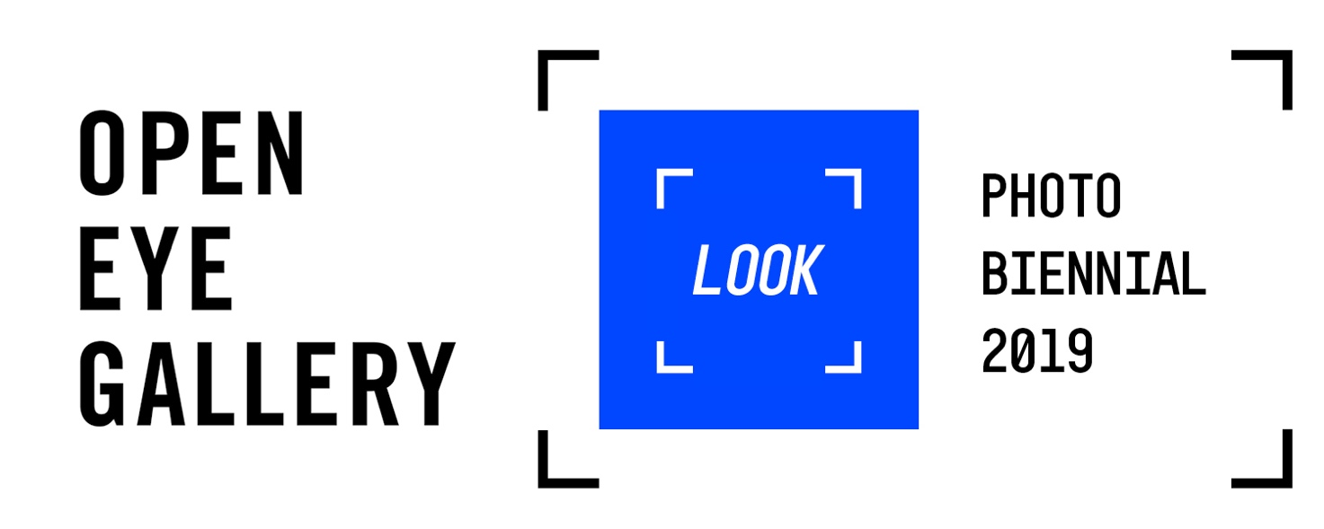

APPLICATION PACK

Thank you for your interest in volunteering for LOOK Photo Biennial 2019. In this application pack you will find background information on the exhibition, a duties description and details of how to apply.

POSITION: Exhibition Assistant
HOURS: 1 day per week (7.5 hours) 9:45 am - 5:15 pm
TYPE: Voluntary

CONTENTS
About the Exhibition
About the Role
Application Form
Equal Opportunities Monitoring Form

ABOUT THE EXHIBITION

Focusing on exchange with China, LOOK Photo Biennial 2019 uses the evolving language of photography to unlock international dialogue. Staged across Liverpool, the wider North West, and Shanghai. The programme sets out to reflect on shifting global identities, worldwide environmental issues and how we can use images to communicate effectively: across borders, technologies and cultures.

Following Chapter One: TRANSPLANT, the second and much more scaled-up chapter is based around two strands: TRANSLATE and TRANSITION.
Forming the centre of LOOK Photo Biennial 2019 is Peer to Peer a group show of 14 artists, selected by 14 curators from across the UK and China. In Liverpool, the exhibition will take place across Open Eye Gallery and the vaulted basement of St. George’s Hall; it will also be shown at Shanghai Centre of Photography in February. The exhibition platforms artists on the verge of major international recognition.
Artists include: UK- Mandy Barker, Anna Ridler, Yan Wang Preston, Sian Davey and Othello De’Souza-Hartley. China- Chen Zhe, Qin Yifeng, Fan Xi, Jiang Pengyi, Alix Marie, Sun Yanchu and Yue Wu.
The core exhibition programme is also supplemented with a satellite programme taking place at venues across the city, including CBS gallery, Buyers Club, Bloom Building, Constellations, The Brink, Baltic Creative, Make Hamilton Square, and Dark Side Art Lab. All artists were selected from an open call and many are local practitioners receiving their first exhibition.

ABOUT THE ROLE

This role will run as part of Open Eye Gallery’s long established volunteer programme. We are keen to encourage individuals from any cultural or educational background to apply, and we hope we can offer broad development opportunities. These range from transferable skills such as public speaking, interpersonal development and creative thinking, to more specialised experience in an art gallery setting, for example, condition checking the artworks, and assisting with exhibition engagement.

Volunteers are an important and valued part of our team. Without volunteers we would not be able to offer this exhibition to the public for free. We want to ensure that volunteering with us helps you to achieve your goals, whatever they may be, and most of all that you enjoy the experience and feel like part of the team.

VOLUNTEER DUTIES

Duties
Visitor Services/Customer Care
- Provide a positive first impression by welcoming and engaging visitors.
- Relay any visitor feedback to the Exhibition Manager.

Gallery Assistance
- Invigilate the gallery space; caring for and ensuring the security of the artworks.
- Offer advice and information to visitors regarding the exhibition and artworks.
- Deal with front-of-house enquiries in a friendly and efficient manner.

Other Duties
- Work as a key member of the exhibition team and contribute to the achievement of its objectives.
- Monitor security and condition of the artworks; reporting any concerns or incidents to the Exhibition Manager.
- Any other duties that may reasonably be required.

APPLICATION FORM

To apply please send a completed application form, outlining what development you wish to gain from your volunteering position, as well as a completed Equal Opportunities Monitoring Form.

Applications should be sent for the attention of Sally Slingsby to Open Eye Gallery, 19 Mann Island, Liverpool L3 1BP or by email to: sally@openeye.org.uk

Position applied for

Surname |  |  |  |  |  | Forenames
Title
Address |  |  |  |  |  | Telephone ☎
 |  |  |  |  |  | Email Address
Postcode |  |  |  |  |  | Date of Birth
Emergency Contact Name:
Emergency Contact Number:
Availability *Please notes that the working day is 9:45am - 5:15pm
 |  |  |  |  | Friday |  |  | Y/N
Wednesday |  | Y/N |  |  | Saturday |  |  | Y/N
Thursday |  | Y/N |  |  | Sunday |  |  | Y/N

You will be required to attend a short induction session and a training day. Please indicate your availability.
Availability

Thursday 10th October | Y/N
Tuesday 15th October | Y/N

Relevant Experience
*Please note experience is not essential.
Career Development Goals
*What do you wish to gain from volunteering?
Disability - Do you have any disability that may require an adjustment to the workplace in order for you to fulfil your duties? |  | Y/N
If you have answered yes, please give details

Convictions - Have you ever been convicted of a criminal offence? Declaration is subject to the Rehabilitation of Offenders Act 1974. | Y/N
If you have answered yes, please give details

Where did you hear about this opportunity?

Please give details of two references
Name |  | Name
Position |  | Position
Address |  | Address
Telephone |  | Telephone
Email |  | Email

If your application is successful, you may be asked to consent to Open Eye Gallery verifying the information provided. Please sign and date the declarations and authorisation below.
I declare that the information given by me, to the best of my knowledge, is true and complete.
In accordance with the Data Protection Act 1998, I hereby authorise Open Eye Gallery to process the information contained in this application form for recruitment and selection purposes.
Name (Block capitals)
Date
Signed

EQUAL OPPORTUNITIES MONITORING FORM

To help us to implement our Equal Opportunities Policy we would be grateful if you would complete this form along with your application. The form will be detached from the application form and the information provided will be confidential and in no way used as part of the selection process.

Gender
Female |  |  | Male
Prefer not to answer
Transgender status – is your gender identity the same as the gender you were assigned at birth?
Yes |  |  | No
Prefer not to answer
How would you describe your ethnic origin?
English/Welsh / Scottish / Northern Irish British |  |  | Irish
Gypsy or Irish Traveller |  |  | Any other White Background
Mixed – White & Black Caribbean |  |  | Mixed – White & Black African
Mixed – White & Asian |  |  | Mixed – Any other mixed/multiple ethnic background
Asian or Asian British - Indian |  |  | Asian or Asian British - Bangladeshi
Asian or Asian British - Chinese |  |  | Asian or Asian British - Pakistani
Black or Black British - African |  |  | Asian or Asian British – Any other Asian background
Black or Black British - Caribbean |  |  | Black or Black British - Any other Black/African/Caribbean background
Arab |  |  | Any Other Ethnic Group
Prefer not to answer
What Age Group Do You Fall In?
0-19 |  |  | 20-34
35-49 |  |  | 50-64
65+ |  |  | Prefer not to answer
Do you have a disability? Any information you provide here will be used for monitoring purposes only – if you need a ‘reasonable adjustment’, then please follow the additional separate process. We will take reasonable steps to meet your particular needs.
Non-Disabled |  |  | Visual impairment
Hearing impairment / Deaf |  |  | Physical disabilities
Cognitive or learning disabilities |  |  | Mental health condition
Not Known /Prefer not to answer |  |  | Other long term/ chronic conditions
Sexual orientation
Heterosexual/ Straight |  |  | Gay woman/lesbian
Gay man |  |  | Bisexual
Other |  |  | Not known / Prefer not to answer
Religious belief
No Religion |  |  | Buddhist
Christian |  |  | Hindu
Jewish |  |  | Muslim
Sikh |  |  | Any Other Religion
Prefer not to answer
Marital status
Married |  |  | Civil Partnership
Single |  |  | Cohabiting with Partner
Divorced |  |  | Prefer not to answer

By completing this form you have helped us better understand how we, as an employer ensure equality of opportunity for all. Thank you.

