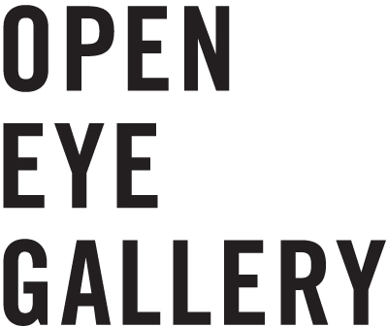
Open Eye Gallery
19 Mann Island
Liverpool Waterfront
L3 1BP

www.openeye.org.uk

+44 (0) 151 236 6768
info@openeye.org.uk

Company Limited by Guarantee No.1204519 &
Registered Charity No.1056743

40 Years of Open Eye Gallery: 1977-2017

2017 Open Eye Gallery will celebrate its 40th birthday. Over this period we have exhibited some of the worlds most inspiring and insightful photographers. We have championed the agency of photography as art, as social and historical document, and as integral to cultural impact of music, fashion, architecture and many other disciplines. We want to celebrate your part in our history. It would be fantastic if you could share a memory using the attached form.

Example Quotes

John Stoddart - Photographer: “Open Eye Gallery, where I was given my first exhibition. They really took me under their wing to be honest. I was only 22 at the time and it encouraged me to do more” – 1981

Colin Wilkinson - Founder of Open Eye Gallery: “Open Eye Gallery, where I was dynamic. We were doing an exhibition a month. It wasn’t madness, it was exciting. Opportunities came up and we took them.” – 1978

Peter Hagerty - Previous Director of Open Eye Gallery: “Open Eye Gallery, where I found out that art can shock people. If you’re not provoking people into thought, what are you doing?” – 1980

Form

Please return all completed forms to Dan Warner, Research Curator, dan@openeye.org.uk.

Name | Email Address | Phone Number
Relationship to Open Eye Gallery (photographer, member of staff, collaborator, visitor)

Quote, 70-140 characters maximum | Date quote relates to
Open Eye Gallery, where I…

Open Eye Gallery, where I…

Open Eye Gallery, where I…

Open Eye Gallery, where I…

Open Eye Gallery, where I…

I give permission for Open Eye Gallery to use my quote/s in relation to their 40th birthday promotion and/or marketing materials. |  |  | YES | N0
I give permission for Open Eye Gallery to add me to their e-newsletter, so I can be kept up to date with their 40th birthday celebrations. |  |  | YES | N0
Signature |  | Date

