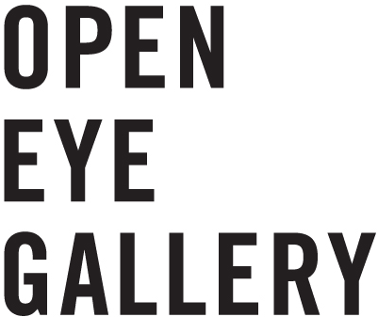
Open Eye Gallery
19 Mann Island
Liverpool Waterfront
L3 1BP

www.openeye.org.uk
+44 (0) 151 236 6768
info@openeye.org.uk

Company Limited by Guarantee No.1204519 &
Registered Charity No.1056743

APPLICATION PACK

Thank you for your interest Open Eye Gallery’s Volunteer Scheme. In this application pack you will find background information on Open Eye Gallery and our Volunteer Scheme, a duties description and details of how to apply.

POSITION: Gallery Assistant
HOURS: 1 day per week (7.50 hours) 10.15-17.45 with occasional evening support.
TYPE: Voluntary

CONTENCE
Page 2 - About Open Eye Gallery
Page 3 - About the Volunteer Scheme
Page 4 - Volunteer Duties
Page 5 - Application Form
Page 7 – Equal Opportunities Monitoring Form

ABOUT OPEN EYE GALLERY

We believe photography is for everyone and can be meaningful, informing our present and inspiring positive futures.

Open Eye Gallery works with people to explore photography’s unique ability to connect, to tell stories, to inquire, to reflect on humanity’s past and present, and to celebrate its diversity and creativity.

Founded in 1977 Open Eye Gallery is an independent not-for-profit photography gallery based in Liverpool.

We are one of the UK’s leading photography spaces, and the only gallery dedicated to photography and related media in the North West of England.

Open Eye Gallery has consistently championed photography as an art form that is relevant to everyone. We promote the practice, enjoyment and understanding of photography by creating challenging and entertaining opportunities to experience and appreciate distinctive, innovative photographs.

As well as presenting a programme of international, high-quality exhibitions we also house a permanent Archive containing photographs from the 1930s to the present day.

We support established and emerging artists, developing practical, critical and professional skills among photography practitioners; we also offer training and development opportunities to people within our local community.

openeye.org.uk
facebook.com/OpenEyeGallery
twitter.com/OpenEyeGallery
instagram.com/openeyegallery

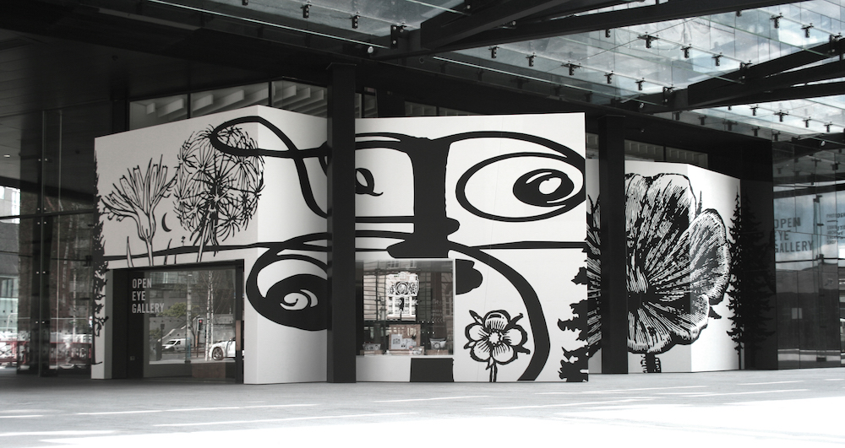
ABOUT THE VOLUNTEER SCHEME

Open Eye Gallery has a long established volunteer programme with a growing community focus. We are keen to encourage individuals from any cultural or educational background to apply we hope we can offer broad development opportunities. These range from;
Retail
- Use of Point of Sale Systems
- Visual Merchandising
- Customer service

I.T.
- Microsoft Office

Transferable skills
- Interpersonal development
- Public Speaking
- Leadership abilities
- Creative thinking
- Problem solving
- Research methodologies
- Organisation skills

Volunteers are an important and valued part of the Open Eye Gallery. Without volunteers Open Eye Gallery would not be able to offer high quality exhibitions and events to the public for free. We want to ensure that volunteering at Open Eye Gallery helps you to achieve your goals, whatever they may be, and most of all that you enjoy the experience and feel like part of the team.

CASE STUDY 2016 | DECLAN CONNOLLY
Like many art graduates, I found landing a relevant job in the art sector really difficult – rather than signing on for benefits I took a job as a bartender and later at a theatre to make up more shifts. As the post-university blues set in, I began to feel culturally strangled – missing the creative circle I had on my university course, so, I quit my paid bar job and began volunteering at Open Eye Gallery In January 2016.

Instantly, the gallery provided the environment I had been craving and actively seeking for some months; I came to look forward to my weekly escape into the wonderful photography collection on the bookshelf, and on the walls of the gallery. I threw myself into what Open Eye had to offer – first, Front of House duties and then researching in the office with the fantastic permanent staff. The gallery team have been thoroughly supportive, asking me to write for the blog and capitalising on my (somewhat obsessive) camera and film knowledge – encouraging me to help with, and later, lead workshops. This is what the Open Eye Gallery family (yes, OEG really feels like family) does: members work out what makes you excited, what you are passionate about and builds it into tangible, workable skills.

Since volunteering, I have comfortably been able to lead tours of 20+ people through the gallery, asked to assist a Magnum photographer and even been put in charge of a paid month-long Biennial Fringe exhibition. In such a short period, I have seen my CV rocket upwards in terms of employability and have made an incredible group of friends from whom I learn something every week.

Thanks to Open Eye Gallery putting me in touch with the right people, I have been offered an internship at Edouard Malingue Gallery in Hong Kong.

VOLUNTEER DUTIES

Duties
Visitor Services/Customer care
- Provide a positive first experience of Open Eye Gallery by welcoming and engaging visitors.
- Deal with enquiries in a friendly and efficient manner, both face to face and over the telephone.
- Process and update visitor data including visitor figures, feedback and research documents in liaison with the Operations Coordinator

Gallery Reception and Information/Assistance
- Invigilate the galleries; caring for and ensuring the security of the artworks.
- Offer advice and information to visitors.
- Manage front-of-house and office enquiries.
- Research and production of the exhibition information packs in liaison with the Curator.

Retail
- Assist the Operations Coordinator with stock orders, storage and returns.
- Monitoring and supervising the maintenance of reception area, operation of the till.
- Assist the Operations Coordinator with any stock taking.

General Administration
- Data Collecting & Filing
- Inputting & Updating Data

Other Duties
- Work as a key member of the Gallery team and contribute to the achievement of its objectives.
- Monitor CCTV and security measures; reporting any concerns or incidents to the Operations Coordinator or member of the Mann Island security team.
- Perform light cleaning where required; including maintaining the appearance of the shop, reception area and galleries and completing regular checks to ensure all public facilities (including toilets) are presented to the highest standards.
- Any other duties that may reasonably be required.

APPLICATION FORM

To apply please send a completed application form, outlining what development you wish to gain from your volunteering position, as well as a completed Equal Opportunities Monitoring Form.

Applications should be sent for the attention of Charlotte Tsang to Open Eye Gallery, 19 Mann Island, Liverpool L3 1BP or by email to: charlotte.t@openeye.org.uk

Position applied for

Surname |  |  |  |  |  | Forenames
Title |  |  |  |  |  | Forenames
Address |  |  |  |  |  | Telephone 
Address |  |  |  |  |  | Email Address
Postcode |  |  |  |  |  | Date of Birth
Emergency Contact Name:
Emergency Contact Number:
Availability *Please notes that the required working day is 10.15-5.45pm
Tuesday |  | Y/N |  |  | Friday |  |  | Y/N
Wednesday |  | Y/N |  |  | Saturday |  |  | Y/N
Thursday |  | Y/N |  |  | Sunday |  |  | Y/N

Relevant Experience
*Please note experience is not essential.
Career Development Goals
*What to you wish to gain from volunteering?
Disability - Do you have any disability that may require an adjustment to the workplace in order for you to fulfil your duties? |  |  | Y/N
If you have answered yes, please give details

Convictions - Have you ever been convicted of a criminal offence? Declaration is subject to the Rehabilitation of Offenders Act 1974. | Y/N
If you have answered yes, please give details

Where did you hear about this opportunity?

Please give details of two references
Name |  | Name
Position |  | Position
Address |  | Address
Telephone |  | Telephone
Email |  | Email

If your application is successful, you may be asked to consent to Open Eye Gallery verifying the information provided. Please sign and date the declarations and authorisation below.
I declare that the information given by me, to the best of my knowledge, is true and complete.
In accordance with the Data Protection Act 1998, I hereby authorise Open Eye Gallery to process the information contained in this application form for recruitment and selection purposes.
Name (Block capitals)
Date
Signed

Would like to be added to Open Eye Gallery’s mailing list? | Y/N

EQUAL OPPORTUNITIES MOINTORING FORM

To help Open Eye Gallery to implement their Equal Opportunities Policy we would be grateful if you would complete this form along with your application. The form will be detached from the application form and the information provided will be confidential and in no way used as part of the selection process.

Gender
Female |  |  | Male
Prefer not to answer
Transgender status – is your gender identity the same as the gender you were assigned at birth?
Yes |  |  | No
Prefer not to answer
How would you describe your ethnic origin?
English/Welsh / Scottish / Northern Irish British |  |  | Irish
Gypsy or Irish Traveller |  |  | Any other White Background
Mixed – White & Black Caribbean |  |  | Mixed – White & Black African
Mixed – White & Asian |  |  | Mixed – Any other mixed/multiple ethnic background
Asian or Asian British - Indian |  |  | Asian or Asian British - Bangladeshi
Asian or Asian British - Chinese |  |  | Asian or Asian British - Pakistani
Black or Black British - African |  |  | Asian or Asian British – Any other Asian background
Black or Black British - Caribbean |  |  | Black or Black British - Any other Black/African/Caribbean background
Arab |  |  | Any Other Ethnic Group
Prefer not to answer
What Age Group Do You Fall In?
0-19 |  |  | 20-34
35-49 |  |  | 50-64
65+ |  |  | Prefer not to answer
Do you have a disability? Any information you provide here will be used for monitoring purposes only – if you need a ‘reasonable adjustment’, then please follow the additional separate process. We will take reasonable steps to meet your particular needs.
Non-Disabled |  |  | Visual impairment
Hearing impairment / Deaf |  |  | Physical disabilities
Cognitive or learning disabilities |  |  | Mental health condition
Not Known /Prefer not to answer |  |  | Other long term/ chronic conditions
Sexual orientation
Heterosexual/ Straight |  |  | Gay woman/lesbian
Gay man |  |  | Bisexual
Other |  |  | Not known / Prefer not to answer
Religious belief
No Religion |  |  | Buddhist
Christian |  |  | Hindu
Jewish |  |  | Muslim
Sikh |  |  | Any Other Religion
Prefer not to answer
Marital status
Married |  |  | Civil Partnership
Single |  |  | Cohabiting with Partner
Divorced |  |  | Prefer not to answer

By completing this form you have helped us better understand how we, as an employer ensure equality of opportunity for all. Thank you.

